Name: Ethan Gabriel E. Soncio  
  
Section: BSCS 3-A AI

Date/Deadline: September 12, 2024

**Step 1: Cloned main repository and created fork repo**

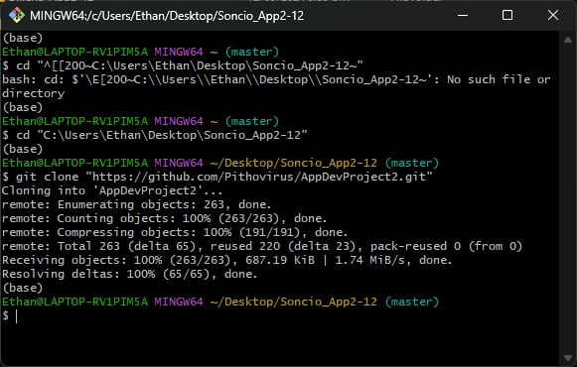

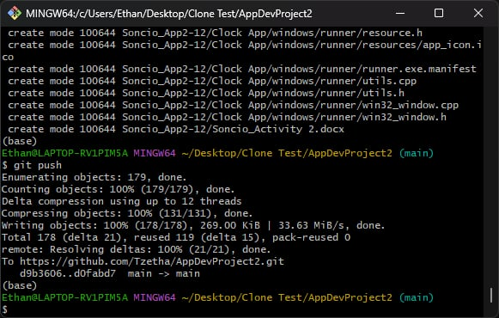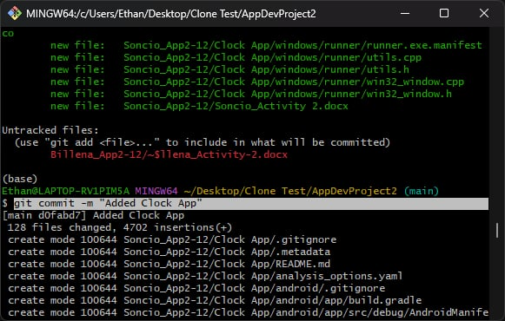**Step 2: Committed and pushed the changes to forked repo**

**Step 3: Initiated a pull request to push the changes made to the main repo**

